ILCA Annual Conference 2023

7-9 September 2023

Postillion Hotel & Convention Centre
Amsterdam, The Netherlands

Promotional Toolkit

Partners/Sponsors

Contents

GENERAL INFORMATION ON ILCA ANNUAL CONFERENCE 2023 3
ONLINE MEDIA MATERIALS 4
Website 4
Newsletter 5
Online Meeting Banner 6
Signature Banner 6
PPT PRESENTATIONS 7
SOCIAL MEDIA MATERIALS 8
Social Media Banners 8
Twitter 8
LinkedIn/Facebook 9

INTRODUCTION

Thank you for supporting ILCA Annual Conference 2023!
To assist you in promoting ILCA AC23, we have provided ready-to-use communication materials. You are welcome to use this information to promote ILCA AC23 on your Social Media platforms, website, newsletters, and any other communication tools you may be using.
For up-to-date information on the programme and overall event, please visit our dedicated website: https://ilcalive.org/annual2023/

We look forward to welcoming you in Amsterdam!

GENERAL INFORMATION ON ILCA ANNUAL CONFERENCE 2023

Event Dates: Thursday 7th June, 11:00 AM CET - Saturday 9th September, 5:15 PM CET
Venue Address: Postilion Convention Centre – Amsterdam
Paul van Vlissingenstraat 8
1096 BK Amsterdam, The Netherlands
For more information on the venue and how to get there, please click here.

If you have any queries, do not hesitate to contact:
Susanna Morató
Email: events@ilca-online.org

ONLINE MEDIA MATERIALS
In this section you will find online media materials for you to use in communicating about and promoting ILCA Annual Conference 2023. You will find ready-made website text, e-mail templates, banners, and other branding materials. If you need any specific material, we can of course provide this for you, please contact:
Susanna Morató
Email: events@ilca-online.org

Website
A sample text you could use for your website to promote the ILCA Annual Conference 2023, as a supporter:
Your Company/Organisation is thrilled to support the ILCA Annual Conference 2023, taking place in Amsterdam on 7th– 9th September 2023.
The #ILCA23 is a must-attend multidisciplinary gathering for liver cancer experts where you can expect state-of-the-art lectures, cutting-edge symposia and the ILCA Tumor Board.. You will get the chance to exchange knowledge and insights with top experts in hepatocellular carcinoma (HCC) and cholangiocarcinoma (CCA) while enjoying Amsterdam's unique charm and plenty of networking opportunities.
For more information, visit https://ilcalive.org/annual2023/ and follow ILCA Twitter Account.

If you wish to use a short description of the event, we have drafted a 50-word brief for your website:

ILCA's Annual Conference is the world's top meeting for liver cancer specialists, providing the perfect platform to share the latest research and techniques, as well as the basic science every professional in the field must master. The conference is a multidisciplinary event, featuring state-of-the-art lectures, cutting-edge symposia, and the ILCA Tumor Board - a must-attend forum for education and advancement in liver cancer.
More information and registration here: https://ilcalive.org/annual2023/

Newsletter

We would appreciate it if you could spread the word about ILCA Annual Conference 2023.
We have drafted an e-mail for you to use, access the e-mail here, simply copy and paste the information in the body of your e-mail.
Please note that you can use all the information or just some parts of it, as it fits best your recipients.

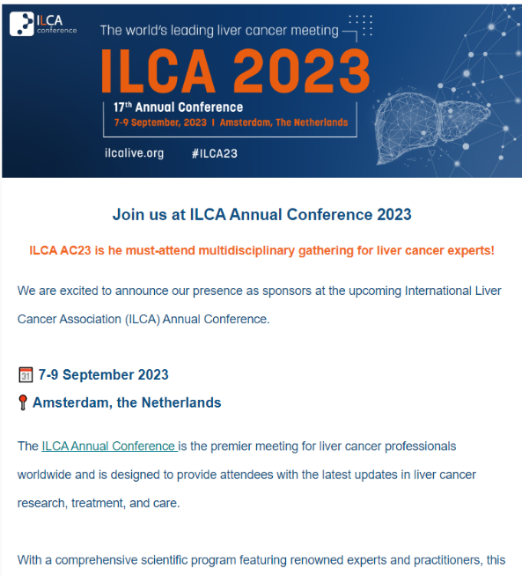

Banners

Online Meeting Banner
Download the banner below and use it as a background screen for your online meetings.

Version 1: download here.

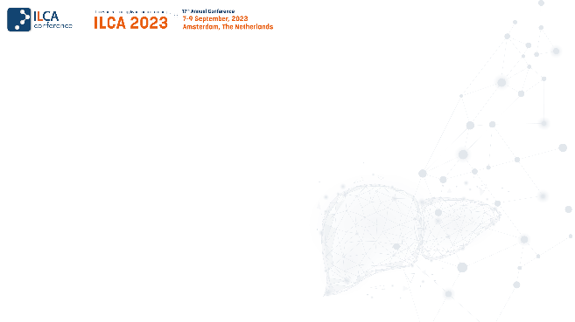

Version 2: download here.

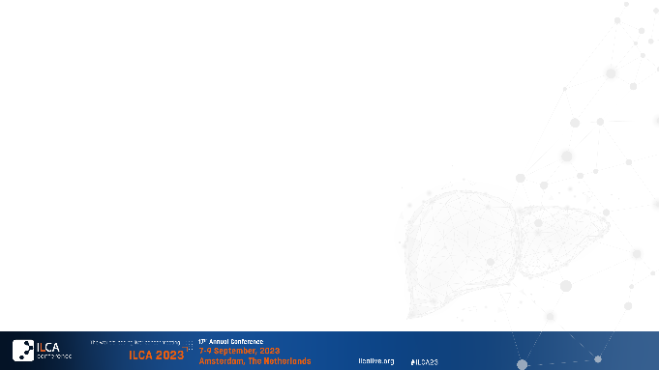

Signature Banner
Download the banner below and use it in your signature.

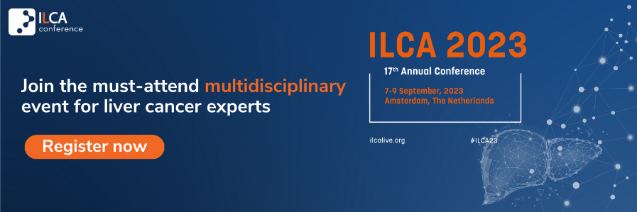

PPT PRESENTATIONS

Invite your network to join the ILCA Annual Conference 2023 by using the PPT presentation found here.

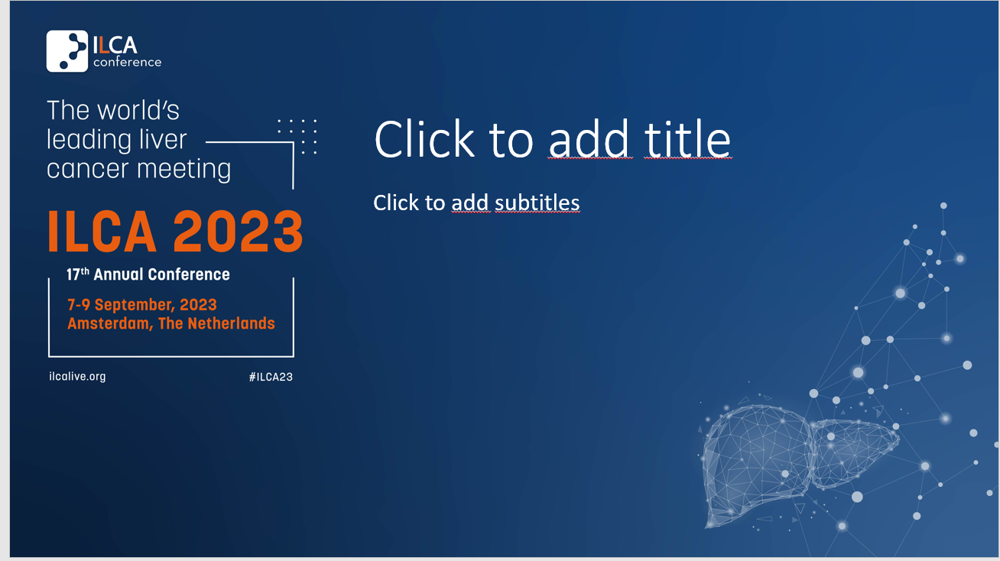

SOCIAL MEDIA MATERIALS

Social Media Banners
Download the web banners here.

Twitter
Regular tweets promoting the event are posted from the ILCA Twitter account: @ILCAnews
We would appreciate if you could follow our account as well as retweet and like our tweets to ensure that we reach a wider, more diverse audience.
When tweeting about the event, to increase engagement, please remember to always include one of the banners, the event’s account @ILCAnews and the hashtag for the event: #ILCA23
We would also appreciate if you tweet from your respective accounts. We have drafted tweets for you to use:

- #1
Join the world's top #livercancer specialists at ILCA's Annual Conference! 🙌
Discover the latest research and techniques, master basic science, and connect with peers at this must-attend multidisciplinary event.
Register now at https://ilcalive.org/annual2023/
#ILCA23

- #2
The #ILCA23 is waiting for you in Amsterdam on 7-9 September! 🥳
The conference promises to bring you state-of-the-art lectures, cutting-edge symposia and interactive sessions on the latest advances in #livercancer
Make sure to save your spot: https://ilcalive.org/annual2023/

- #3
Don't miss out on the world's top #livercancer event!
🗓️ 7-9 September 2023
📍 Amsterdam, The Netherlands
Join us at #ILCA23 to get the latest multidisciplinary updates on liver cancer treatment and care.
Discover more: https://ilcalive.org/annual2023/

LinkedIn/Facebook

Regular updates on LinkedIn and Facebook promoting the event are posted from the ILCA LinkedIn account and ILCA Facebook account.

We would appreciate if you followed the account as well as shared and liked our posts to ensure that we reach a wider, more diverse audience.

To increase engagement, please remember to always include one of the banners, our account and the hashtag for the event: #ILCA23
We would also appreciate if you post from your respective accounts. We have a post for you to use:

(Company name) is excited to announce that the #ILCA23 is coming to Amsterdam on 7-9 September! 🎉
As the world's leading liver cancer meeting, the conference promises to deliver state-of-the-art lectures, cutting-edge symposia, and interactive sessions on the latest advances in liver cancer. This multidisciplinary event is a must-attend for liver cancer specialists looking to stay up-to-date with the latest research, techniques, and basic science, while also connecting with peers in the field.
Take advantage of this opportunity to connect, learn, and grow in your career. International Liver Cancer Association (ILCA) awaits you at the Postillion Hotel in Amsterdam. 📍
Don't miss out on this unparalleled opportunity - register now at https://ilcalive.org/annual2023/
#ILCA23 #livercancer

If you have any question do not hesitate to contact:

Susanna Morató
Email: events@ilca-online.org

